OF MINE AND MINES −A BRIEF LOOK AT DESCENDANTS OF ALEXANDER BASCH IN SOUTH AFRICA

by Sam J Basch sam@koisan.co.za
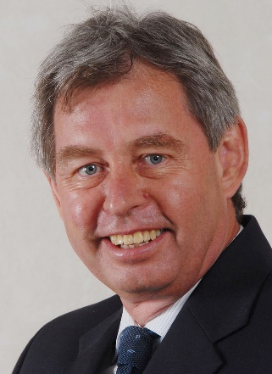
Born in 1952 in Springs, where he attended school, Sam J Basch completed military service before obtaining a degree in Communication Science. He had a long career in the South African diplomatic service and later at a state-owned company. At present he does freelance journalism, text editing and photography. Sam and Anna (born Marx) have three children, one who now resides in London. Other interests include photography and writing for foreign journals on aviation

Introduction

We know very little of Alexander Basch. We know his name Alexander Oskar Adolf Berthold Basch and some bare facts of his later life, that’s all.

Whenever we introduce ourselves, people often exclaim: “Basch? What a curious surname! First time I’ve heard it. There are probably not many of you in South Africa?”

That’s true, to a degree. His surname was more or less subsumed into new families when his daughters got married, but at least some male descendants carried it into the present.

How they had fared since Alexander Basch set foot in this country in the mid-1800s requires a much broader outline than the mere brushstrokes in the following pages. However, the picture we have for now is one of relative depravation – not dissimilar to that of many Afrikaner families at the time.

Alexander Oskar Adolf Berthold BASCH (1837-1902)

We know the young man with an impressive set of first names came from northern Europe, specifically from the Neisse distrikrict of Breslau in the erstwhile Prussian province of Silesia.

At that time, Breslau was a German city, the largest in Silesia (pronounced Schlesien in German). Today Breslau is called Wroclaw, after the incorporation of large parts of Silesia into Poland in the aftermath of World War II.

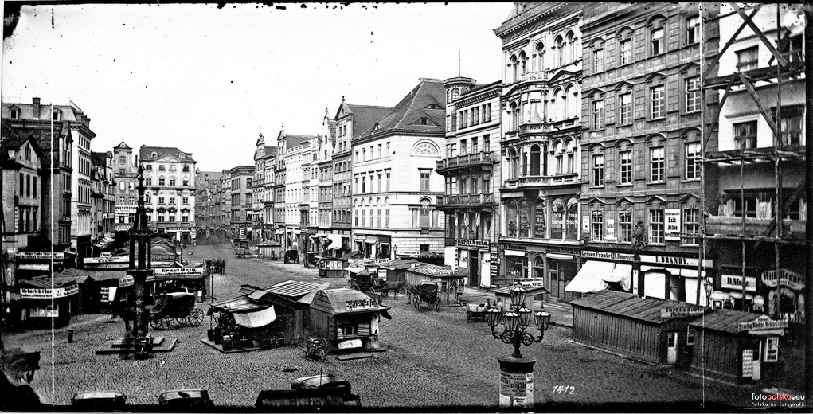
Breslau in 1873 - Photo: Fotopolska-Eu

It is unclear when exactly, or by which route, Alexander came to South Africa. His parents were Gustaaf Adolf Frederick and Christina Laura BASCH, who presumably remained in his homeland. He was a blacksmith, skilled at building and repairing wagons and wheels (also described as a wheelwright), who later acquired a portion of Elandskloof near present-day Dullstroom where he farmed until his death at the end of the Anglo-Boer War (1899-1902).

Let's pause for a moment in Silesia.

This Polish province is generally divided into Lower and Upper Silesia, with the former along Germany's eastern border considered the more attractive part. Upper Silesia borders the Czech Republic. Nysa, one of the oldest towns in Silesia and previously called Neisse, the distrikrict from which Alexander emigrated, verges on the Upper Silesian industrial region in the east of the province. Here we find steel plants and coal mines, which eerily point to the industry that would absorb many of Alexander's descendants.
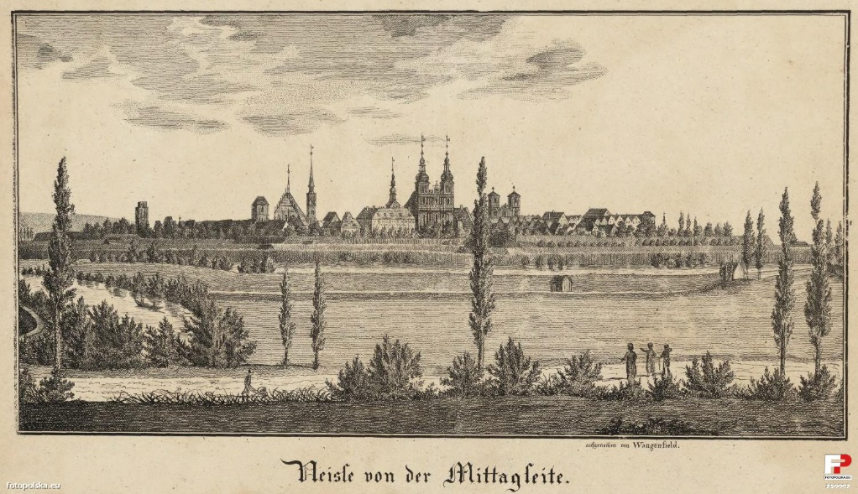
Neisse in 1851, around the time Alexander Basch was growing up in the area - Photo: Fotopolska-Eu

The record shows he got married to the 29-year-old Martha Smit in 1861 in the Lydenburg distrikrict of the South African Republic (ZAR - Zuid-Afrikaansche Republiek). She died in 1870 when her fourth child was about 18 months old, after which Alexander married Aletta Petronella STOLTZ, with whom he fathered 11 children.

He was already 62 years old at the outbreak of the Anglo-Boer War, but played his part in the conflict, along with some of his sons. (The female family members, including his wife Aletta, suffered the fate of many Boer women, namely being driven from their devastated farms to face the horrors of the British concentration camps.)

British intelligence reports confirmed that a heliograph station operated on Elandskloof in February 1902. In these reports several references are made to AFC Bass (Assistant Field Cornet?) with 40 men at Roodeklip and evacuating Elandskloof in March 1902, as well as FC Bass (Field Cornet?) with 70 men at Elandskloof on 6 April 1902.

Alexander Oscar Adolf Berthold BASCH (1872-1948)

It is surmised that 'FC Bass' and 'AFC Bass' refer to Alexander Basch and his 29-year-old son, who shared his father's full names. This is borne out by the younger Alexander's post-war application for a war medal in which he indicated his rank as 'Asst Veldkornet' during campaigns in the Steenkampsberg area. Some of his senior officers included Gen Ben Viljoen and Gen Muller, both mentioned in the British intelligence reports on activities in this area. Moreover, corrupting an unusual surname like 'Basch' could easily have occurred, especially if intelligence officers were relying on verbal reports.

An intriguing supposition is that Alexander (father) was killed for operating the heliograph station on Elandskloof. His widow Aletta stated in her compensation claim for war damages that her husband "was murdered by the Native [sic] during the late war on the 20th of April 1901 [sic]". This event took place "2 miles from Dullstroom" – probably close to or on Elandskloof where he was buried. A 14-year-old boy Robert Gert, presumably his youngest son, had also been murdered there on the same day. Both were subsequently re-interred at Bergendal near Belfast, where their names appear on the war memorial, along with those of other fallen Boer combatants.

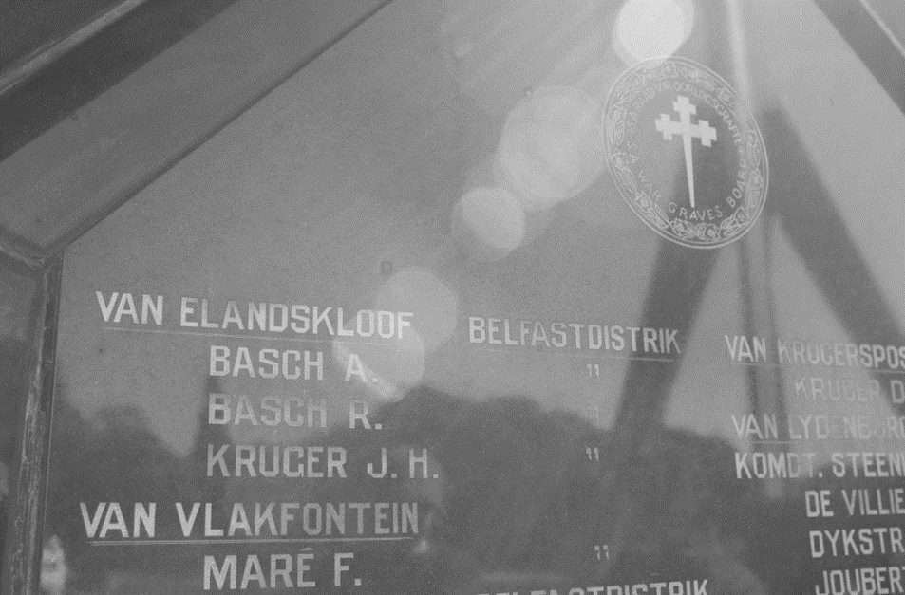
Basch names at Bergendal - Photo: Author]

The younger Alexander was a 'Bittereinder' (Bitter-ender) who laid down arms at Belfast in June 1902, and was transferred to the Barberton concentration camp "sent here to join his family." A baby son of his had died there in 1901.

After the war Alexander took his wife Hester Maria COMBRINK and young family to Eldoret in Kenya, where they remained until shortly before World War I. Alexander and Hester had ten children, the youngest of which, Johannes (Hannes) Jacobus Basch, was apparently murdered on the mines, according to a great-grandson of Alexander who now lives in the United States.

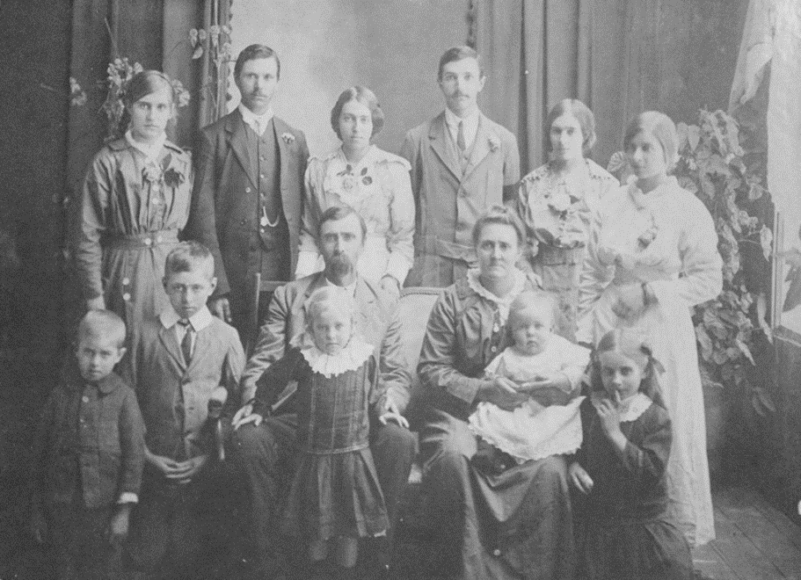

The Alexander Basch family, ca. 1912. The boy 2nd from left was also christened Alexander, presumably after the progenitor - Photo: courtesy of Hilton Supra

Alexander's descendants now reside all over thew orld. He died at the age of 76 in Pretoria, having retired from the South African Railways.

Samuel (Sampie) Jacobus BASCH (1868-1934)
The elder Alexander's youngest son from his first marriage, Samuel (Sampie) Basch, was an ordinary combatant ('Burger') in the war, having fought at Magersfontein where he was wounded on 6 December 1899, and at Dalmunatha, along with his half-brother Alexander. The author is in possession of his 'Lint voor Wonden' (a medal and ribbon for war wounded).
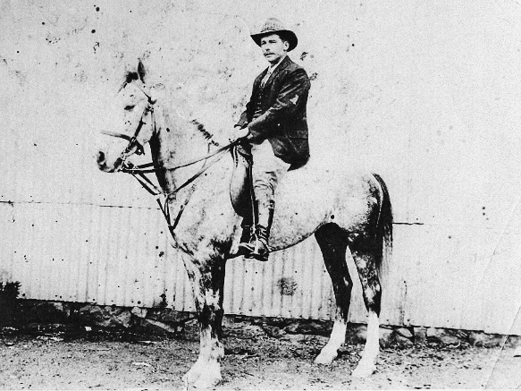

Burger Sampie Basch on his horse - Photo: courtesy of Gus Basch]

Sampie grew up on the farm Welgelegen in the erstwhile Eastern Transvaal where his father Alexander dwelt with a new wife Aletta and her relatives who farmed in the distrikrict. The four young children from the first marriage ranged in ages from nine years (the eldest Gustav Adolf Frederik) to the 3-year-old baby Sampie. Soon the family would expand as Aletta gave birth to her own children.however, in time Sampie ventured out to Stellaland and ultimately to the Lichtenburg area. The local Carolina newspaper reporting on his death in 1934 claimed Sampie was 21 years old when he left for Stellaland. His age is probably incorrectly stated, as this would imply the date to be around 1889 – when the Stellaland Republic no longer existed. One has to assume he was much younger, probably 17 years old, because the newspaper reported that "they [including his compatriots] could not bear living under English [British] rule there, and then moved to Lichtenburg distrikrict where he lived until the outbreak of the war 1899-1902." It should be recalled that the British had concerns about ZAR expansion to the west, which prompted them to send a force under Sir Charles Warren to occupy the territory.

In his application for a war medal, Sampie indicated that he had served in the Lichtenburg Commando and later in the Carolina Commando.

It was in the Carolina area that he met his future wife Alida VAN WYK whose father owned a portion of the farm Vanwyksvlei. At the time of their marriage in 1904, their prospects would have been bleak. Like many other farms in the distrikrict Vanwyksvlei was devastated in the war, with even the homestead destroyed.

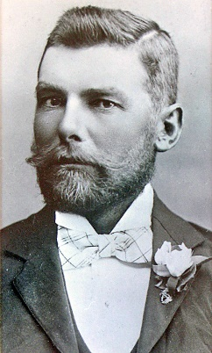

Sampie Basch in formal attire, presumably on his wedding day in 1904 - Photo: Basch Collection

“Hierdie aardling het geleer, dat die volgende geslag, nie wat ons besit het die meeste gaan waardeer nie, maar die bewyse van wie ons was en die stories van hoe ons liefgehad het. Op die ou end is dit die familiestories wat die waardevolste is wat bewaar moet word.” - Ellen Goodman,

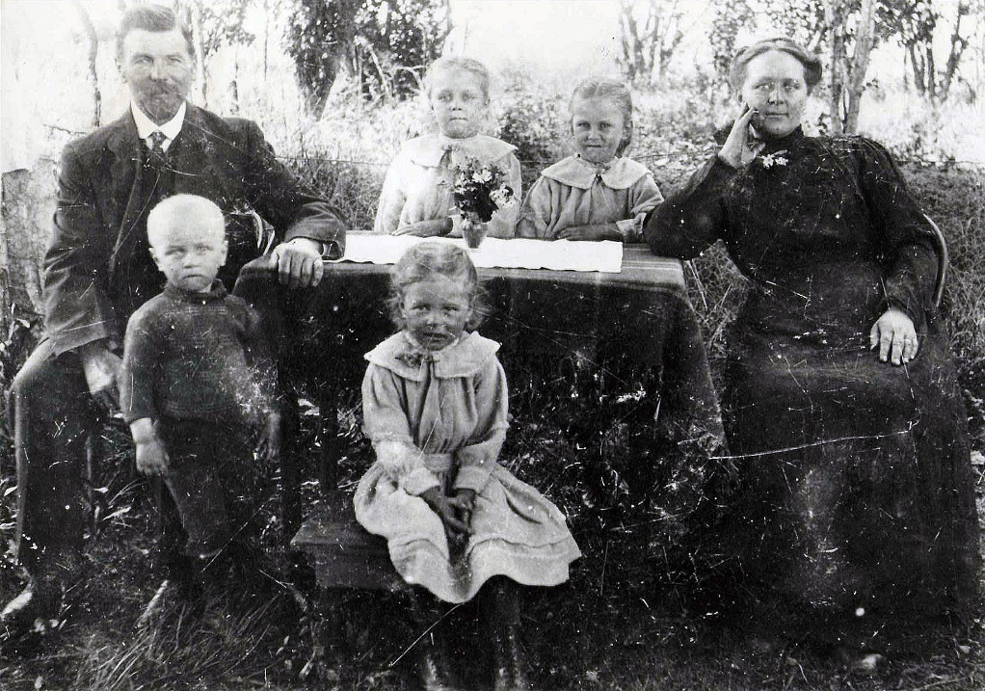
Sampie and Alie Basch with their first four children on Vanwyksvlei, ca. 1914 - Photo: Basch Collection]

Still, they raised eight children there, seven of whom grew to adulthood. When Sampie died of pneumonia on 4 October 1934 at age 65, he was buried on Vanwyksvlei, alongside a daughter Elsie Magdalena who had died young. Both graves are covered with a crumbling cement slab and still lack a headstone with a name. His portion of the farm measuring 686 morgen 3 square roods was sold at public auction in 1935 for £1 483.
His widow Alida (called Alie) and her remaining children had to seek a livelihood elsewhere. Poignantly, her lawyer wrote an appeal on her behalf:
In conclusion, the survivor has asked me to write you and obtain your permission to her retaining the household furniture, which consists of ordinary and simple farm household furniture, valued at approximately £15. This will be all she will get out of the estate and will be greatly appreciated by her.

The mines:

We are now in the midst of the Great Depression. Compounding the economic calamity was a serious drought that lasted into the 1930s. While many Afrikaner families still eked out a living on farms, migration to the cities had already begun in the late 19th century, especially to Johannesburg and surrounding towns where gold was being mined.

It is noteworthy to read ZAR President Paul Kruger's reaction in 1885 to news of the discovery of gold:

Do not talk to me of gold, the element which brings more dissension, misfortune and unexpected plagues in its trails than benefits... I tell you today that every ounce of gold taken from the bowels of our soil will yet have to be weighed up with rivers of tears.

Edward-John Bottomley in his book 'Poor White' has this to say:

In 1890 fewer than 10 000 Afrikaners (between 2 and 3 per cent) were urbanised. Less than 50 years later, 535 000 (50 per cent) lived in towns and cities. The centre of this accelerated modernity was the gold-bearing reef of the Witwatersrand, an area stretching about 60 kilometers from Springs in the east to Krugersdorp in the west.

This is precisely where Alie headed with her family: to the East Rand town of Springs, originally renowned for coal, but then surrounded by gold mines. They faced a precarious existence, as her children were hardly skilled for the industrial economy (Gustav the youngest was only nine years old).
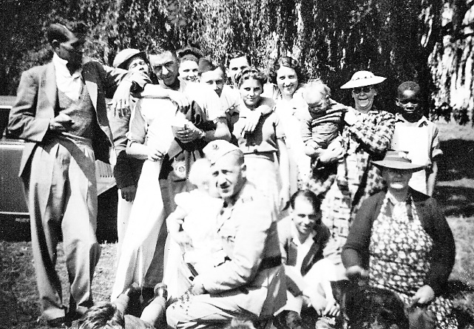

Alie Basch, front right, with her children and friends at a picnic in Springs, ca. 1939. Her son Sam sits on her right - Photo: Basch Collection]

Gilliomee stated that Afrikaners moving to the cities found that "skilled and semi-skilled work, the professions and civil service positions were already filled by local or immigrant English-speakers." (p.318). The options for many Afrikaners, and black people, consisted mostly of positions for unskilled labour.

Many Afrikaners now migrating to the cities and towns ended up in dire poverty, living in slums and eating "mealie-pap and water", as Bottomley reported.

The Transvaal Indigency Commission (TIC), appointed by Lord Alfred Milner, investigated the issue of poor whites in the post-war years of 1906 to 1908, followed by the Carnegie Commission in 1932. The latter found that 42 per cent of housing for the poor were 'unfit for habitation.'
Whilst Alie and the children in her household did not actually live a slum-like existence, it is a fact that they were poor. Her fourth child, the 24-year-old son Alexander (called Louis) was likely the one who first found a position on the gold mines in Springs.

Was he perhaps the one who managed to find a house in which the family could live, whilst the boys tried to earn an income? A photograph in the Basch collection shows the young brothers with friends in the scruffy backyard of a humble home in Casseldale, a suburb of Springs.

Alexander (Louis) died of broncho-pneumonia at the age of 33, leaving his wife Anna SNYMAN and a baby boy, also Alexander (Alec), who was born less than two weeks previously. His Death Notice shows his occupation as 'Myner' (miner) living at Dunnottar, south of Springs, at Nigel, another small gold mining town on the East Rand.

Samuel (Sam) Jacobus BASCH (1918-1980)

This third son of Alie was 16 years old when his father Sampie died in 1934. We are indebted to his drawing skills for a graphic layout of the farm cemetery at Vanwyksvlei, showing the unmarked grave in which his father Sampie was buried.

Personal recollections of the author bring to mind how Sam related taking on any job that could supplement the family's income. This included working for the then-popular OK Bazaars in nearby Benoni until 1937 and as a debt collector for Williams Hunt & Harris, running these errands on a Norton motorcycle. The company was a dealership for Chevrolet and Buick motorcars.

He ultimately found a position on the gold mines, being transferred over the years, from Geduld to Blyvooruitsicht (near Carletonville to the west of the Witwatersrand) to Modderbee and Daggafontein in Springs, with a stint at Winkelhaak mine near Evander. With no matric Sam took to studying part-time towards a post-matric equivalent qualification, resulting in a long career as principal of the Government Miners' Training Schools (GMTS).

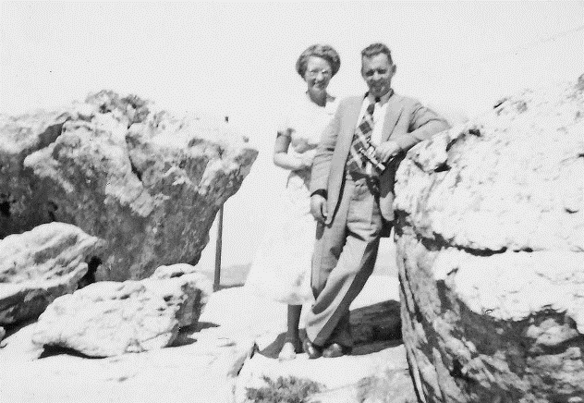
Sam Basch with his new bride Grieta, born Van der Vyver, 1951 - Photo: Basch Collection]

In 1951 he married newly qualified nursing sister Margaretha (Grieta) VAN DER VYVER, whom he had met in Pretoria. They settled in Springs, where Sam owned a house in the suburb of Selection Park. Grieta's mother and sister occupied a house across the road from them, and Sam eventually assisted his brother-in-law (Grieta's brother Pieter) to obtain a position on the mines, too.

Their four sons grew up on the mines, principally at Daggafontein, where they lived a very modest yet carefree, almost rural lifestyle, with farmland close by and a steam train branch line to the centre of Springs. The mine provided a self-contained yet rigid class stratified existence, as renowned Springs-born novelist and activist Nadine Gordimer, wrote:

The white people on the mines of the Witwatersrand began their life together lost in many kinds of isolation; yet, speaking of the past, anyone who lived there will give the strongest impression of security. Mining people not only worked together; they lived close in Company houses along Company streets, tended by a mine doctor in the mine hospital, meet at the mine Recreation Club for their entertainment... We were just like one big family in those days. What other way could there have been in that emptiness, that memoryless place? It was an autocratic family, of course, and the social hierarchy, based on the hierarchy of working importance, provided the sense of order. The General Manager's in his residence; all's well with the world.

Sam took early retirement from the mines in 1972 to join Sanlam where he pursued a successful second career until his death in 1980. He lies buried in the Springs cemetery, not far from his mother Alida.

Conclusion:

Notwithstanding the mines' somewhat tarnished reputation in South Africa today, they did have a major impact on the economic development of the country – and that of many displaced Afrikaner families.

As Davenport said: "Nowhere else in the world has a mineral revolution proved so influential in weaving the political, economic and social fabric of a society."

Other factors played an equally important role, e.g. government policies aimed at uplifting poor whites. Prime Minister JBM Hertzog's 'civilised' work policy of 1924 was instrumental in giving preference to the employment of unskilled white workers in state departments and enterprises like the railways.

Within five years the number of unskilled whites in the employ of the South African Railways and Harbours (S.A.R. & H.) had climbed to 16 000 (28,7% of the total), from less than 5 000 (9,5% of the total).

Having taken a brief look at only some individuals from the Basch family, descendants of the progenitor Alexander Oskar Adolf Berthold, we noted that many others also found a livelihood within the public sector. Space constraints here preclude the painting of a broader canvas.

Suffice it then to say that Alexander's descendants today can take pride in the achievements of their kin despite hardships many suffered, often throughout their lives. Many of the current generation of descendants now reside all over South Africa and abroad, contributing their now considerable skills to the modern economy.

Casting our minds back to Silesia, it is noteworthy that Polish society has always had great respect for industrial workers for their 'calling' or vocation, where the profession has often been passed from father to son. 'Barborka' is the annual Miners' Day, celebrated on 4 December.

Extract from the BASCH family register:

Alexander Oskar Adolf Berthold *Neisse distrik, Breslau (now Wroclaw, Poland), Prussia 02.08.1837 † Elandskloof, Lydenburg distrik. 20.04.1902 (farmer and blacksmith) Ω Bergendal x Lydenburg 17.11.1861 Martha Christina Elizabeth Geertruida SMIT *Beaufort Wes 24.09.1837 † Lydenburg 31.07.1870 xx Lydenburg 02.10.1872 Aletta Petronella Margaretha STOLTZ *11.02.1848 † Middelburg 23.04.1920

b1 Gustaaf Adolf Frederik ∗*29.08.1862 ≈Lydenburg 01.01.1863 † Geluk, Carolina distrik 13.01.1898 (farmer) x Lydenburg 12.03.1888 Aletta Susanna VAN LOGGERENBERG † 15.10.1913

b2 Johanna (Hannie) Margaretha *14.03.1865 ≈ Lydenburg 22.10.1865 † Zondagskraal 26.06.1929 x Lydenburg, Henning Jacobus (Koos) VAN WYK *21.8.1865 † Vanwyksvlei 3.3.1923

b3 Christina Laura *01.1867 ≈ 10.03.1867 Nasareth distrik. Middelburg † 07.10.1921 x Carolina, Francois Cornelis MEYER

b4 Samuel (Sampie) Jacobus *Vanwyksvlei, distrik Carolina 19.12.1868 † Vanwyksvlei 03.10.1934 x Carolina, Tvl. 27.04.1904 Alida (Alie) Wilhelmina VAN WYK *05.09.1885 † Springs 12.05.1961

c1 Carolina Wilhelmina *Vanwyksvlei 05.05.1905 † Witbank 30.09.1959 x Jacobus Johannes Hercules STEYN *21.03.1898 † Witbank 27.08.1947

c2 Martha (Peggy) Christina Gertruida *Vanwyksvlei, Carolina distrik 31.08.1906 † Nelspruit 01.03.1974 x Witbank 18.04.1936 Edmund (Ed) Hamilton DAVIE *Harrismith 11.10.1905 † Nelspruit 28.10.1996

c3 Alida (Lida, pronounced Laida) Wilhelmina *Vanwyksvlei 18.03.1908 † Pretoria 18.07.1966 x Carolina 17.03.1928 Hendrik (Baasman) Christoffel DE CLERCQ *Carolina 28.01.1908 † Pretoria 21.12.1965 (his farm Paardeplaas near Carolina was eventually sold to a coal mining company)

c4 Alexander (Louis) Oscar Adolf Berholdt *Vanwyksvlei 09.1910 (Miner, lived at Dunnottar) † Springs 11.08.1943 x Springs, Anna Magdalena SNYMAN

c5 Arie Willem *06.10.1914 † Johannesburg 08.07.1970 x Bloemhof 08.08.1944 Lilian Esther COLEMAN

c6 Samuel (Sam) Jacobus *Vanwyksvlei 16.08.1918 † Springs 23.03.1980 (principal of GMTS mine school, later Sanlam representative) x Springs 31.03.1951 Margaretha (Grieta) Elizabeth Johanna VAN DER VYVER *Laingsburg 29.10.1927 † Springs 29.07.2001

c7 Elsie Magdalena *24.11.1920 † Vanwyksvlei 19.07.1924

c8 Gustav Adolf Frederick *Vanwyksvlei 13.01.1926 † Johannesburg 19.02.1981 x Elizabeth Magdalena Johanna STEYN

Alexander's second marriage with Aletta Stoltz:

b5 Alexander Oscar Adolf Berthold *c1872 † Pretoria 14.12.1948 (retired from South African Railways, Pretoria) x Hester Maria COMBRINK

b6 Gabriel Gert Frederik *Vanwyksvlei, Carolina distrik. *01.1875 † battlefield, Dundee distrik. Natal 13.05.1900 (reburied Pretoria 16.01.1929) x Lydenburg Maria Magdalena BOTHA *03.1882 † Concentration camp Belfast 04.02.1902

b7 Anna Cornelia Margaretha *Carolina 04.1875 † Pretoria 04.10.1948 x Jan Hendrik COMBRINK † 1907 xx James Gladstone TURNER † 17.06.1942

b8 Richard Adolf *Frischgewaagd, Carolina distrik. 19.08.1877 † Pretoria 11.06.1960 x Carolina 10.11.1914 Martha Elizabeth VISSER *Beetgeskraal, Lydenburg distrik. 02.05.1894

b9 Aletta Petronella Margaretha x Thomas Kemp WAKEFORD / WHITEFORD

b10 Maria Geertruida (Magdalena) *Carolina distrik 04.1882 † Johannesburg 22.08.1954 x Albertus Hendrik BEZUIDENHOUT † 1957

b11 Elizabeth Jacomina Aletta *Distrik Carolina 11.04.1883 † Wryneb near Rayton, Bronkhorstspruit distrik 12.01.1954 x Isaac GOBEY *England 01.1876 † Wryneb farm, Rayton 24.09.1954

b12 Hester Izabella Aletta *30.11.1885 x Philippus MARÉ

b13 Martha Christina Elizabeth Geertruida *01.02.1889 † 22.08.1953

b14 Gert (George) Coenraad Frederik *01.06.1891 † 26.10.1918 x Elizabeth Margaretha VENTER *10.1915 † Edenvale Hosp. 03.08.1959 (epidemic, presumably Spanish flu) (fitter on SA Railways) xx Harold Daniel SMITH

b15 Robert Gert † 04.03.1902 Elandskloof, Lydenburg distrik Ω Bergendal from Elandskloof

Sources:

- TAB MHG Ref 2782 for Alexander OAB Basch (1837-1902)
- TAB MHG Ref 0/19326 (incorrectly archived as BOSCH instead of BASCH) for Martha Smit (1837-1870)
- Ancestry24 (information posted by 'cornestoltz', read on 19 May 2012 for Aletta Stoltz (1848-1920)
- British Concentration Camps of the South African War 1900-1902, http://www2.lib.uct.ac.za/mss/bccd/Person/111164/Aletta_Petronella_Basch - accessed 11 May 2013
- TAB MHG Ref 63/49 for Alexander OAB Basch (1872-1948)
- Email correspondence with Hilton Supra, Helen Supra (born Tiedt) and Fritz Tiedt, descendants of progenitor Alexander OAB Basch from his second marriage, starting 4 January 2013
- JP Stoltz, Stoltz/Stols van Suid-Afrika - Herinnerings-/gedenkrol vanaf 1712, Publiself Uitgewers, November 2009
- 1984 Voters' Roll on Basch voters
- Diverse documents and photographs in author's private possession (Basch Collection), e.g. copy of Sampie and Alie's marriage certificate issued by the Ned H of G Kerk, Carolina 21.12.1945
- Personal recollections and conversations with relatives over many years
- TAB MHG Ref 3960/43 for Alexander OAB Basch (1910-1943)
- TAB MHG Ref 7069/59 for Carolina Wilhelmina Steyn, born Basch (1905-1959)
- TAB MHG Ref 6498/66 for Alida Wilhelmina De Clercq, born Basch (1908-1966)
- TAB MHG Ref 7620/70 for Arie Basch (1914-1970)
- Sam Basch (1918-1980) marriage certificate and death certificate in author's private possession (Basch Collection)
- Sampie Basch obituary in The Advertiser (Carolina), 12 October 1934, from his friend Hennie Prinsloo and an obituary datelined Carolina, 26 October 1934 (newspaper title not indicated)
- Leon Strachan, Son of England, Man of Africa, Tartan Publishers, 2nd revised edition 2009
- Email correspondence with Elria Wessels, senior researcher at Anglo-Boer War Museum, Bloemfontein
- Edward-John Bottomley, Poor White, Tafelberg, 2012
- Prof CFJ Muller, (ed.), 500 Years - A History of South Africa, 3rd Edition, H&R Academia, 1969
- Jade Davenport, Digging Deep - A History of Mining in South Africa, Jonathan Ball Publishers, 2013.
- Martin Meredith, Diamonds, Gold and War - The Making of South Africa, Jonathan Ball Publishers, 2007
- Frank Welsh, A History of South Africa, HarperCollins Publishers, London, 2000
- Eyewitness Travel, Poland, Dorling Kindersley Limited, A Penguin Company, London, 2007
- Tian Schutte, Guerrillastryd - Minder bekende skermutselings en gevegte in die Transvaal tydens die guerrillafase van die Anglo-Boereoorlog, 2016
- Coal Mining in Upper Silesia and Heavy Industry in Poland during Communism, http://culture.polishsite.us/articles/art301fr.htm - accessed in October 2016
- Silesia facts, information, pictures, http://www.encyclopedia.com/places/germany-scandinavia-and-central-europe/polish-political-geography/silesia - accessed in October 2016
- Silesia - Wikipedia, https://en.wikipedia.org/wiki/Silesia - accessed in October 2016
- Charles van Onselen, The Fox and the Flies - The World of Joseph Silver, Racketeer and Psychopath, Jonathan Cape, London, 2007
- David Goldblatt & Nadine Gordimer, On The Mines, C. Struik (Pty) Ltd., Cape Town, 1973
- Email correspondence with Dr Tian Schutte, Nelspruit, commencing 26 August 2014 through 27 June 2016, who supplied copies of numerous historic documents, including British intelligence reports from the British Archives at Kew, London
- Jerzy Lukowski & Hubert Zawadzki, A Concise History of Poland, 2nd Edition, Cambridge University Press, 2006

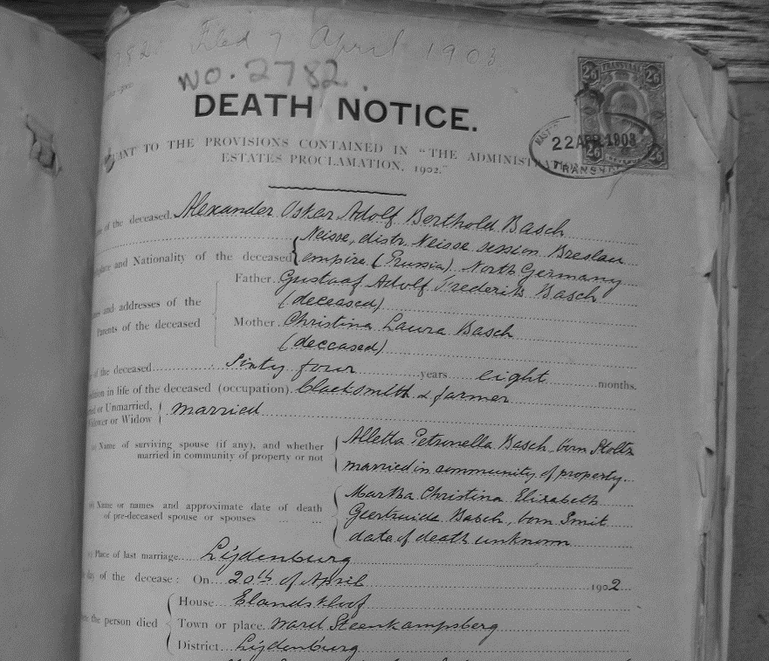
Alexander Oskar Adolf Berthold Basch se Sterfkennis

His Death Notice in Afrikaans recorded the birthplace as: ‘Neisse Distrikrict, Neisse Session, Breslau, empire (Prussia), North Germany’
Currently a trout farm owned by the COMBRINK family, descendants of a COMBRINK-BASCH marriage
Martha Christina Elizabeth Geertruida SMIT (1837-1870), d.o. Samuel Jacobus SMIT (1798-1837) and Johanna Margaretha DU PLOOY (1804-1885)
The author’s grandfather, Samuel Jacobus BASCH (1868-1934)
Daughter of Gabriël Gerhardus Frederik STOLTZ (1819-1885) and Anna Cornelia Margaretha GROBLER * 1819
Alexander's Death Notice (DN) shows only 10 children from his second marriage
His Death Notice and other sources confirm he died in 1902.
Elria Wessels, Anglo-Boer War Museum, in an email dated 23 October 2009.
The memorial wall for Burger Deaths on Commando at the Anglo-Boer War Museum in Bloemfontein shows their date of death as 4 March 1902
Her brother Jan Hendrik COMBRINK married Alexander's sister Anna Cornelia Margaretha BASCH
The short-lived Stellaland Republiek existed from 1882 to 1883, then joined the neighbouring State of Goshen to form the United States of Stellaland until 1885. Following its annexation by the ZAR, the British abolished the republic and incorporated it into British Bechuanaland (now Botswana).
Title unknown, dated 29 October 1934
Alida Wilhelmina VAN WYK (1885-1961), daughter of Arie Willem VAN WYK (1842-1928) and Carolina Wilhelmina BESTER
Town lawyer HJ Grobler in Carolina, an appeal on 29 April 1935, presumably to the Master of the Court
Editor of the Pretoria Press, Leo Weinthal, as quoted by Martin Meredith in Diamonds, Gold and War
Herman Gilliomee, The Afrikaners, quoted by Edward-John Bottomley in Poor White, p.34
Her three daughters were grown-up, already married or soon to be married, and living elsewhere, including Carolina and Witbank (a coal mining town)
The Modderbee prison outside Springs is now located on the site of the old mine
Besides numerous awards, Gordimer won the Nobel Prize for Literature in 1991
Jade Davenport, Digging Deep - A History of Mining in South Africa, p.1
Prof CFJ Muller, (ed.), 500 Years - A History of South Africa, p.416
Presumably youngest son of progenitor AOAB BASCH - no birth records found. Murdered on 20 April 1902 along with AOAB Basch at Elandskloof, re-interred at Bergendal

